Battery Monitor 2 Software Description

My requirements for dome shutter operation have evolved with experience, some of it painful:

1. Ability to supply external power to the shutter in the event of combined primary and backup power failures.
2. Ability to open and close the shutter externally for both ease of normal maintenance and emergency access in the event of a catastrophic power or system failure.
3. Ability to close the shutter remotely even if primary power to the dome is interrupted.
4. Ability to recharge the backup battery even if primary power to the dome is interrupted.
5. Ability to monitor backup battery charge state and health continuously and remotely.

The dome power and control subsystem that meets these requirements is shown below.

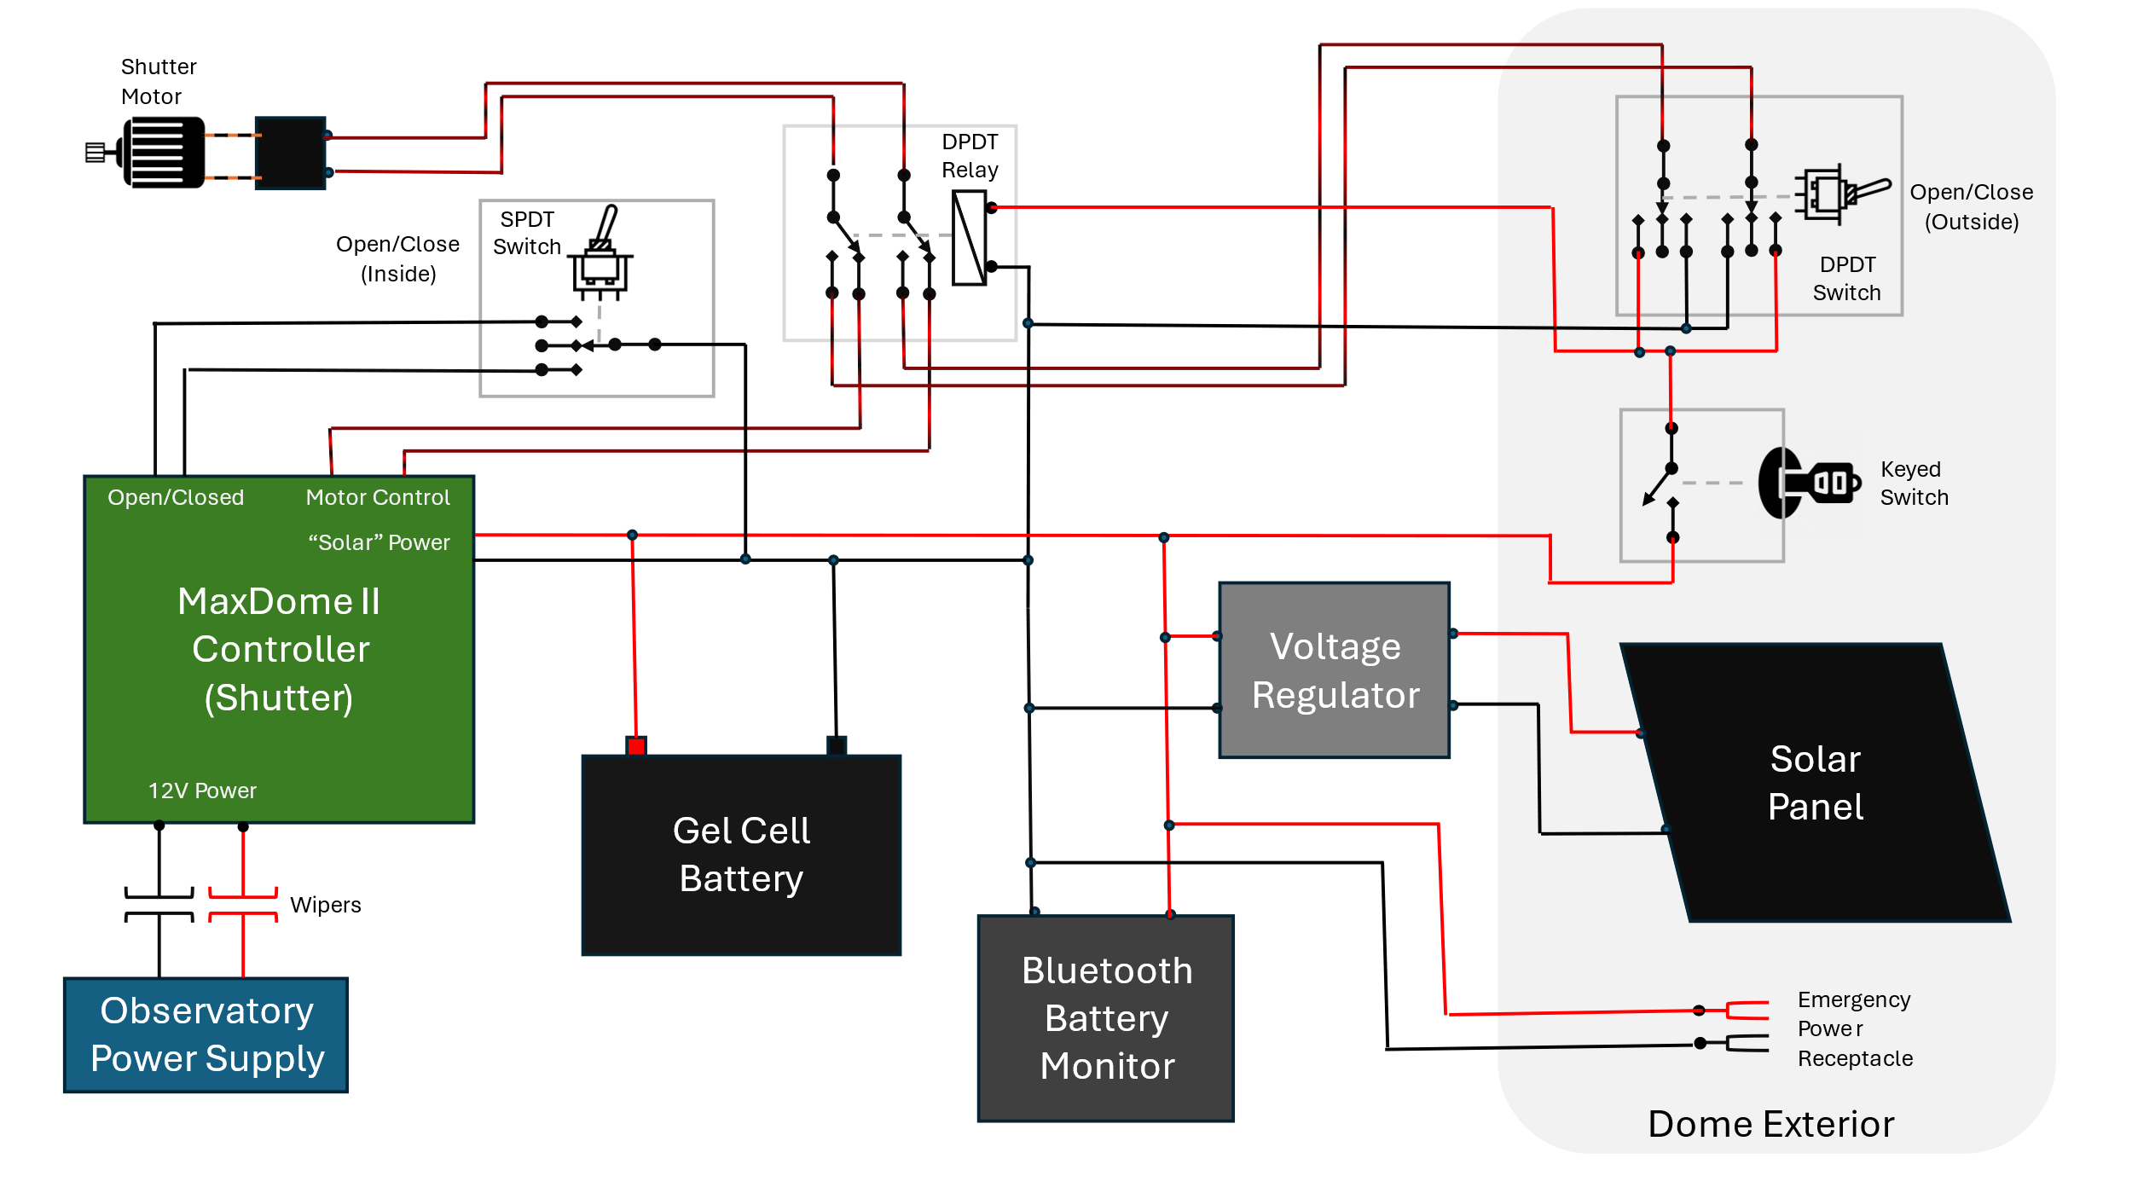

Figure 1: Dome Power Subsystem

In this system there are four sources of power to the dome:

1. Primary power from the base power supply through wipers.
2. Back up power from a small gel-cell battery.
3. Solar power from a small, dome-mounted solar panel for recharging the battery, if needed.
4. External terminals for use if all other sources fail.

The dome has two switches for opening and closing the shutter, one mounted on the inside of the dome and connected to the dome electronics and one mounted on the external side of the dome which bypasses the dome electronics. A keyed switch on the outside of the dome prevents “unauthorized” use.

Per recommendation, I’ve mounted a small gel-cell battery in the upper dome to supply backup power to close the dome door in the event that connection to power from the base through the wipers fails. Prior to opening or closing the door, normally the dome is rotated to its park position which aligns wipers for supplying power. However, a general power outage, software failure, misaligned or corroded wiper contacts can create a situation where the shutter cannot be opened or closed without this backup power.

The solar panel is solely for recharging the battery in the event of primary power interruption (e.g. supply failure, corroded and/or misaligned wipers) and is connected through a voltage regulator to isolate the panel and protect the backup battery from overcharging.

The Bluetooth battery monitor provides a means to remotely observe the voltage level in the dome power system and the associated charge state of the backup battery in real time. The client end of this monitor runs via simple Windows application on the observatory computer. The software is free and downloadable from GitHub.

Figure 2: Battery, Voltage Regulator and Battery Monitor

